

**Proposal for Falcon Solutions**

**Executive Summary**

**Lockheed Cartin’**

**Date: 6/07/21**

**Lockheed Cartin’ Point of Contact**:

Victoria Condos, Program Manager

201-274-3859

victoria.r.condos@lmco.com

**Table of Contents**

1 Setting The Bar 2

2 A Winning Concept 3

3 Our CART For Falcon Solutions 5

3.1 Design Breakdown 5

*3.1.1* *Frame and Body* 5

*3.1.2* *Steering* 5

*3.1.3* *Propeller* 5

*3.1.4* *Electronics Control and Connectivity* 5

3.2 Mission 6

3.3 Design Philosophy 6

4 Planning for success 6

4.1 Meet the Team 6

List of Figures

Figure 1. Customer Requirement Hierarchal Chart.

Figure 2. CONOPS Diagram.

**Figure 3.** Team Breakdown

# Setting The Bar

The following requirements have been designated as Key Performance Parameters (KPPs) as they are the most critical to the success of the Cargo—Augmenting Rotational Transmission (CART) system designed by Team Lockheed Cartin’.

1. The CART system shall be propelled by a pusher propeller.
   1. The pusher propeller shall have OTS propeller blades.
   2. The CART system shall be self-powered by an Arduino Uno.
   3. Build instructions for the CART system shall be provided to the designated ELDP.
2. The CART system shall have remote control functionality.
   1. The CART system shall accept wireless commands from up to 110 feet.
3. The CART system shall have the ability to travel a maximum 110 feet.
   1. The CART system shall require a maximum of 1 battery swap.
   2. The CART shall operate for a maximum of 20 minutes.
4. The CART system shall prevent physical damage to system handlers.
   1. The CART system shall prevent unsafe electrical discharge to system handlers.
   2. The CART system shall prevent circuit overloads.

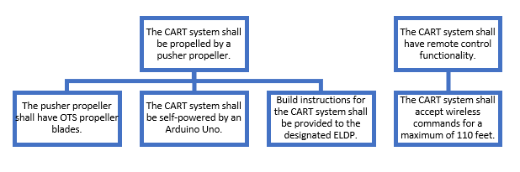

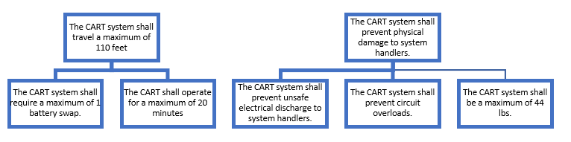

**Figure 1. Customer Requirement Hierarchal Chart.**

This figure outlines the requirements agreed between our team and Falcon Solutions It shows the how the requirements flow into each other~~.~~

# A Winning Concept

This project is operating fully remote and will be executed cradle to grave following the systems engineering process. The goal of this project is to create an autonomous cart that has the ability to travel down a one hundred foot straight path in the fastest time to its competitors with remote control functionality.

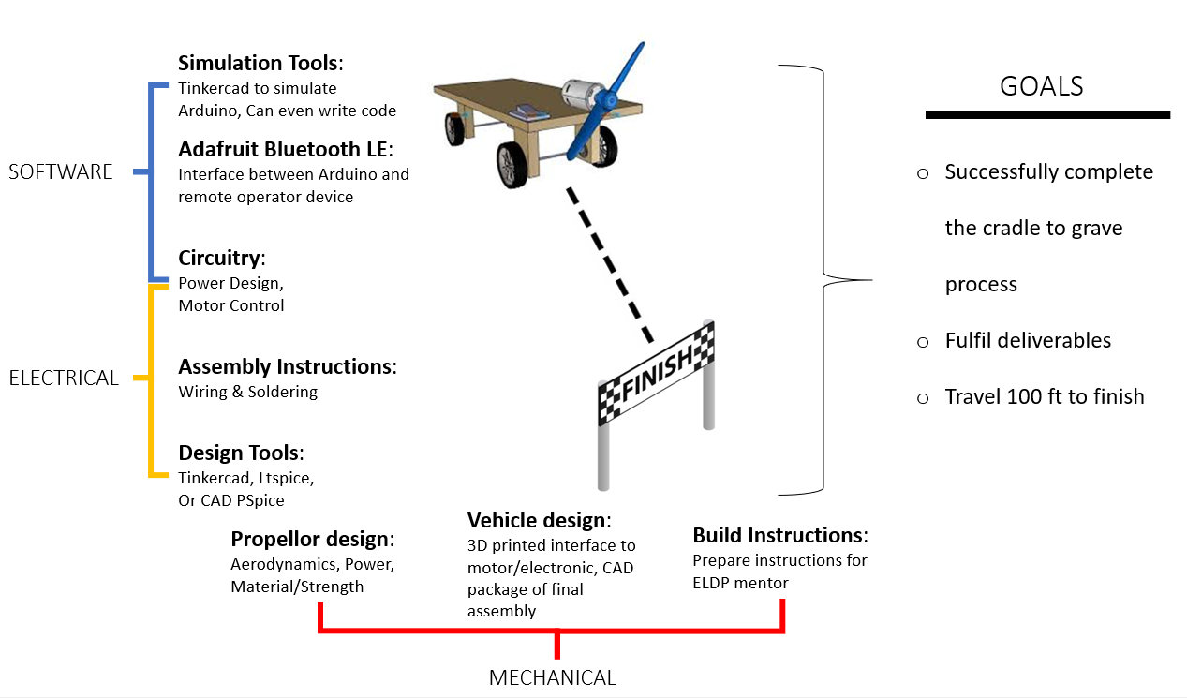

**Figure 2. CONOPS Diagram.**

The diagram gives an example run through made by the racing CART. It lists out different aspects to outline how the drone functions to reach its end goal in the race.

The physical design of the cart has three main categories that are equally as important, mechanical, electrical, and software.

1. The mechanical portion will primarily deal with the propeller and vehicle design as well as the detailed build instructions.
2. The electrical portion will revolve around circuitry, assembly instructions for the wiring and soldering, and the use of design tools to verify the process.
3. The software portions will deal with the power and motor control, the Adafruit Bluetooth LE, and the use of simulation tools to verify their processes.

Similar to the SB>1 DEFIANT, the cart will receive its main source of thrust from a pusher propeller, these blades will be Off The Shelf (OTS) due to the increase in performance and reliability when working with the other components of the cart. Along with the blade design, there needs to be focus on weight distribution, due to many of the components needing to be connected or closely placed to each other there is a high possibility that the cart could tip easily. The importance of understanding where and how much weight to add will be able to mitigate this issue. With the use of simulation tools, such as Tinker CAD Arduino, much of the design logistics can be done through this program. This program allows a simulated testing program where components such as bread boards, Arduino Uno’s, and Bluetooth receivers can all be wired up and tested to ensure the planned set up would work accordingly.

# Our CART For FALCON SOLUTIONS

## Design Breakdown

### *Frame and Body*

### Utilization of a pre-designed frame allows for complete focus on providing the best propeller and electronics design possible for extended range, efficiency, and speed. The provided frame will 3D printed from ABS and will be roughly 5” x 7” x ½” and includes two axles with four bearings and wheels. Lockheed Cartin’ has chosen to stick with two axles and four wheels to reduce the rolling resistance of the CART system. To further improve the air resistance and stability of the CART, Lockheed Cartin’ plans to add a 3D-printed body to cover the frame and electronics. This body will likely have an airfoil like shape when viewed from the top.

### *Steering*

Lockheed Cartin’ also aims to provide the CART with the ability to steer via a servo that turns the motor, changing the thrust angle about the yaw axis. This will allow the CART to correct its mission path based on data from the onboard accelerometer. Additionally, the choice to include steering will allow for Lockheed Cartin’s design to be utilized on non-linear tracks in addition to the requested linear track mission, allowing for a versatile CART system that can be utilized for more complex missions in the future.

### *Propeller*

Lockheed Cartin’ will be utilizing an Off The Shelf (OTS) propeller for the CART system. Many things were considered when making this decision. Firstly was the performance of an OTS propeller when compared to a 3D printed propeller. A 3D printed propeller is likely to be unbalanced and thus cause vibrations when spinning at the maximum motor RPM. This would likely cause errors in the accelerometer that will control the tracking of the cart and help send position data back to the ground station. Additionally, a 3D printed propeller is more likely to fail than an OTS option as 3D printing has layer lines that create points of failure on any part produced, a safety concern on a propeller undergoing high RPM loads for extended periods of time. Finally, 3D printing a propeller would require lots of sanding to achieve a smooth blade for efficient operation, resulting in many man hours that create additional costs. All of these negative effects can be negated by utilizing an OTS propeller in addition to allowing for more design time on more mission critical components of the CART system.

### *Electronics Control and Connectivity*

For the main computer the CART System will utilize an Arduino UNO board as requested by Falcon Systems. Additionally, a Bluetooth module called the Adafruit Bluefruit LE, also specified by Falcon Solutions, will be utilized to accept wireless commands to the CART system and transmit mission data back to the operator at a range of up to 100 feet. Servos will be utilized as mentioned in Section 3.1.2 and will be run off of the Arduino Uno. A motor and motor controller as specified by Falcon Solutions will be utilized to propel the CART system. For power the CART system will utilize a 12 volt battery bank will be utilized for the Arduino, servos, and motor.

## Mission

As requested by Falcon Solutions, the Bluetooth module mentioned in Section 3.1.4 will be utilized to accept mission commands, in addition to transmitting mission critical data back to the operator, both at a range of up to 100 feet. To decrease the overall time necessary to travel 100 feet, a key mission goal, Lockheed Cartin’ is planning to reverse the direction that the motor is spinning, therefore reversing the thrust, allowing for a faster deceleration. This CART design will allow for the best possible accuracy and speed to complete the mission.

## Design Philosophy

### The success of this design will be helped in part by the simplicity of the mechanical design, with a large focus being placed on the electrical and software design. Lockheed Cartin’ aims to complete the mechanical design of the CART system early in development, allowing for a focus on the electronics and software for the remaining design time. The software is the main point of concern, especially without the ability to test the CART system prior to delivery to Falcon Solutions. Thus, this is Lockheed Cartin’s likeliest point of failure for the CART system, which is why such a large focus will be placed on it.

# Planning for success

Here at Lockheed Cartin’, we gave a lot of consideration into creating a CART that satisfies all of Falcon Solutions’ requirements and will be able to complete a simple CART race as proposed in the SOW. We believe that with any good concept, there needs to be a strong plan and team behind it or else the quality of the product is not up to par.

Our PM’s primary focus is to be the link between our team and Falcon Solutions. We will provide informative progress reports to keep Falcon Solutions in the loop. Our DPM and Operating Manager will work with our PM to ensure that the team stays on track. Our plan is to move forward after this proposal by keeping the requirements in mind and beginning to gather the needed materials. Once we create a functional CART, we plan to host a review panel for any changes or improvements that Falcon Solutions would like to suggest, ensuring that our CART meets Falcon Solutions’ standards. We are certain that in involving Falcon Solutions on every step of the way, we can work through prototyping and building our cart efficiently and confidently.

## Meet the Team

Our team is made up of a Program Manager (PM), a Deputy Program Manager (DPM) and Finance Lead, a Manager of Operations, a Software Department, a Hardware Department, a Systems Lead, a Test Engineer, and a Human Factors Engineer.

Victoria is the team’s PM due to her previous experience as program manager for last year’s intern project as well as her communication and time management skills. The PM Will make sure that each team member is getting their work done and communicating well with each other. The PM will also act as a liaison between the customer and team to make sure all customer requirements are being met.

Bobby is the team’s Manager of Operations. In this position, he will work directly with Madison, the team’s DPM and finance lead, in order to oversee the business side of the project and to assist Victoria. Bobby studies Supply Chain Management and will be an asset for all things business and budgeting.

Madison is the team’s DPM and Finance Lead. As a double major in Finance and Marketing, Madison’s education will help guide the team in tracking cost and projecting profit to ensure that the team stays within budget. Also, as DPM, Madison will work directly with Bobby to aid Victoria in making sure all project requirements are met.

Rebecca and Cassidy are the team’s Software Engineers. Rebecca is currently studying Computer Engineering while Cassidy is studying Computer Science. Rebecca and Cassidy will collaborate with Cassidy focusing on the coding aspect while Rebecca focuses on the Arduino Uno aspect as those are each of their areas of expertise.

Kiefer is the team’s System Engineer. Kiefer will be an asset in this position due to his background in Mechanical Engineering and is currently in an internship role that revolves around manufacturing engineering. Kiefer has experience with CAD programs and applications of electrical engineering which he will use to create our CART’s system.

Ben and Alex are the team’s Mechanical Engineers. Both team members study Aerospace Engineering, so they have previous experience with 3D printing, CA and remote controlled aircraft that use similar power systems to the propelled cart that we will be creating. Currently, Alex serves as a Hardware Engineering intern, and Ben serves as a Blade Engineering intern. Ben and Alex will collaborate to plan and create the design of our final product as well as assist with any other technical tasks that will be required along the way.

Veronica Leto is the team’s Test Engineer. Veronica studies Aerospace Engineering, and is has been a member of her university’s high powered rocketry competition teams throughout her college career. In her role on the high powered rocketry competition team, Veronica aided in designing and constructing the structural components of her team’s vehicle, and she has experience designing and analyzing structural components with CAD and Finite Element Analysis software which will help her to be successful in her role as Test Engineer.

Kyleen Crowe is the team’s Human Factors Engineer. As a double major in Psychology and Social Work, Kyleen is able to use her knowledge of human behavior to aid the team in creating a control mechanism and overall design that will improve the vehicles overall functionality and use.

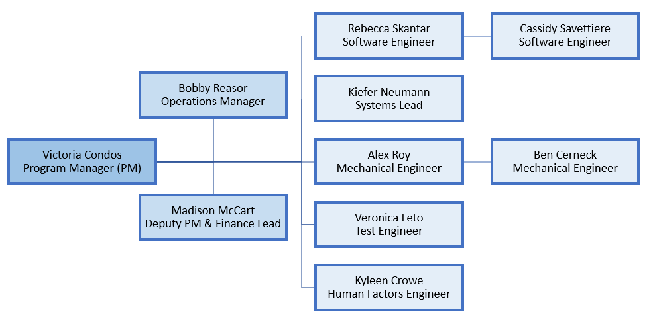

**Figure 3. Team Breakdown**

The figure above outlines how our team operates while highlighting the key members and their respective position.



**Proposal for Falcon Solutions**

**Lockheed Cartin’**

**Acronym Table**

**Appendix A**

**Date: 6/16/20**

**Appendix A: Acronym List**

|  |  |
| --- | --- |
| CART | Cargo-Augmenting Rotational Transmission |
| KPP | Key Performance Parameters |
| PM | Program Manager |
| DPM | Deputy Program Manager |
| OTS | Off The Shelf |
| SOW | Statement of Work |
|  |  |
|  |  |
|  |  |
|  |  |
|  |  |